**Computer Vision - MIMIC ME REPORT**

**Malathi Sankar**

**1.1 Display Feature Points**

Iterated feature points on the face object and added a circle at the location of the feature point

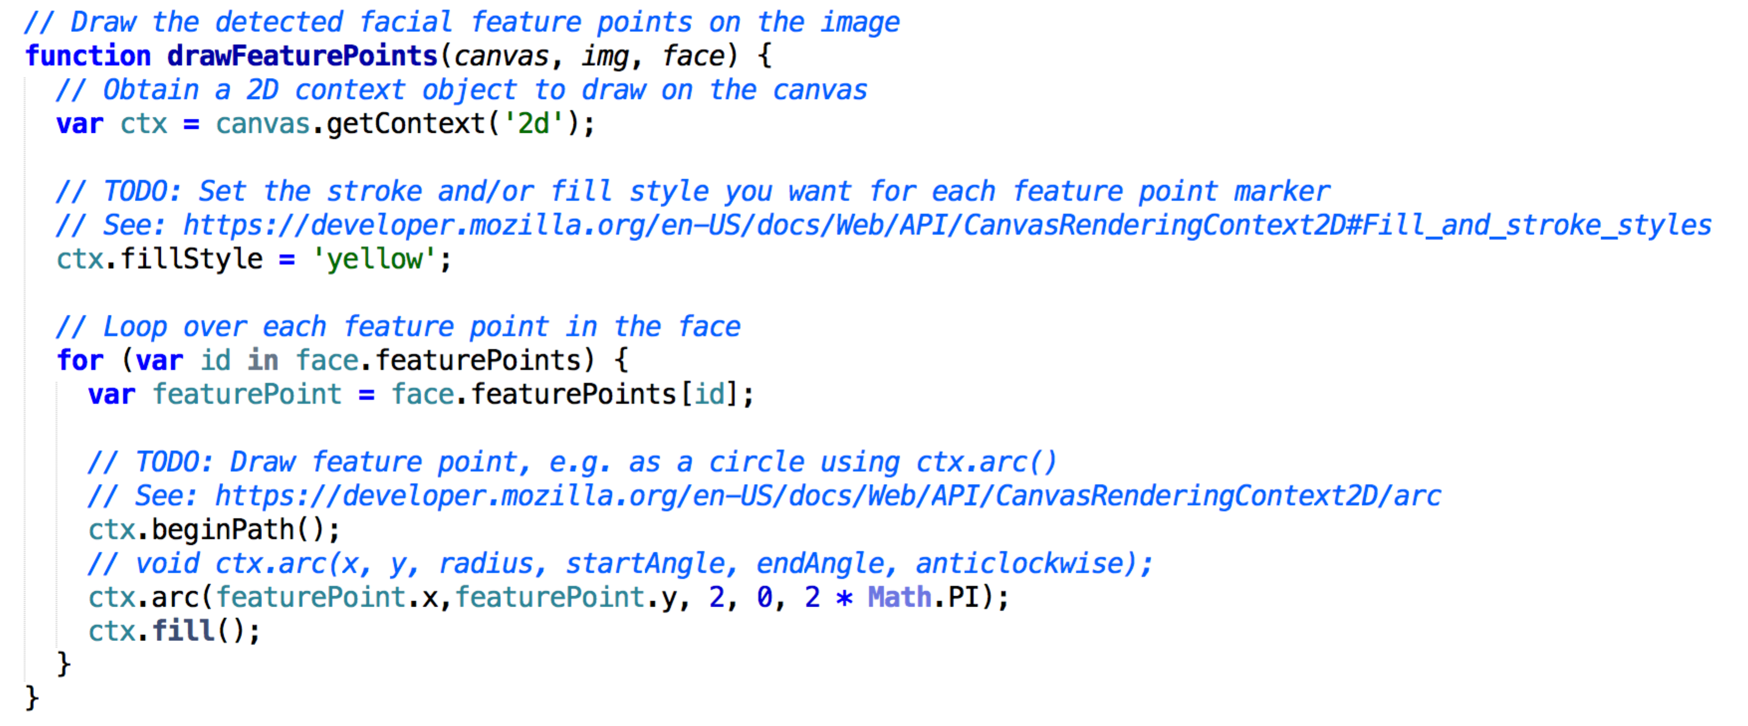

**1.2 Show Dominant Emoji**

Obtain the dominant emoji from the face object. Displayed it at feature point 3 with a size of 56px.

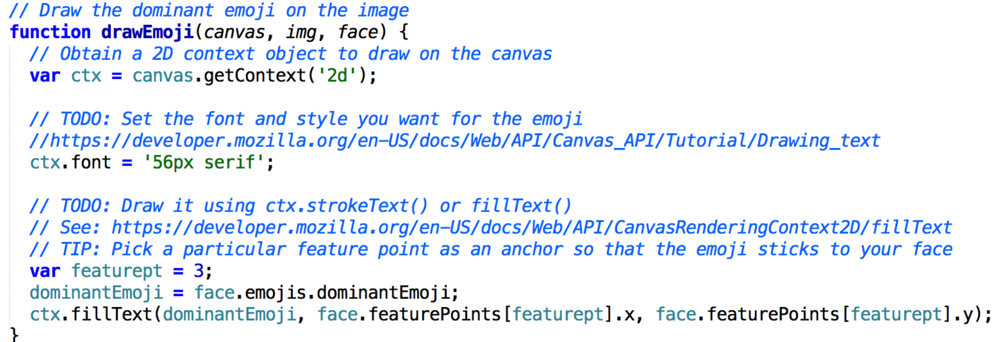

**1.3 Implement Mimic Me!**

Initialize variables for the game

var emojis = [ 128528, 9786, 128515, 128524, 128527, 128521, 128535, 128539, 128540, 128542, 128545, 128563, 128561 ];

var currentScore = 0;

var totalScore = 0;

var timeleft = 0;

var timer = 0;

var targetEmoji = 0;

Initialize the game. This is called from onInitializeSuccess event.

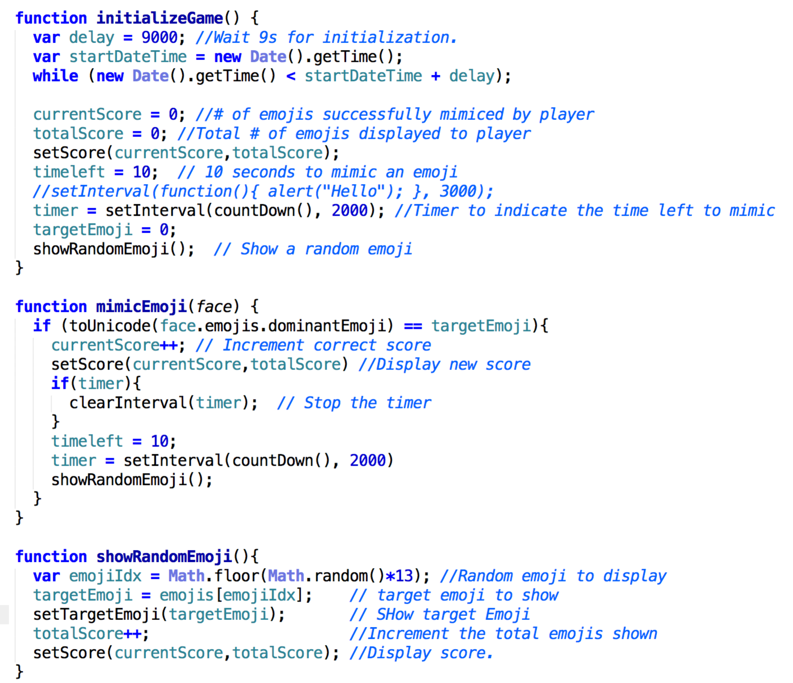

Restart Game

This is called from onReset() function

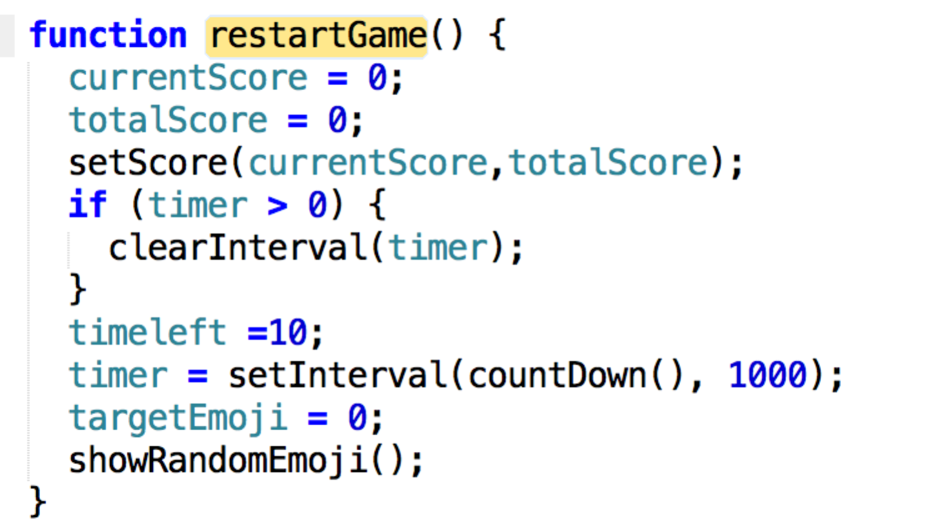

Stop Game

This is invoked from onStop().

